**LAB ASSIGNMENT -4 (CISCO PACKET TRACER – ACL)**

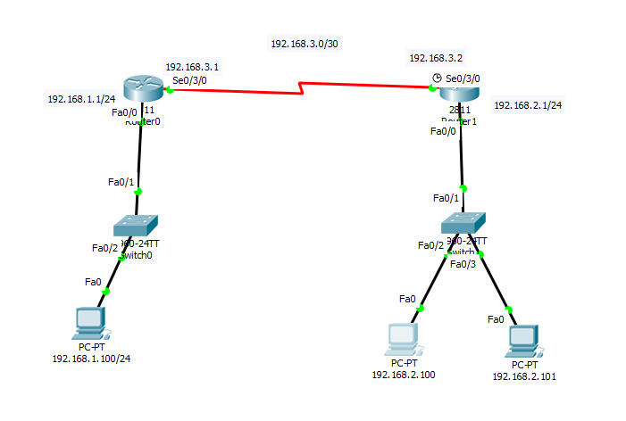

Q4) Make above scenario using cisco packet tracer and configure router manually.

1. Apply standard access control list (ACL) on outbound interface fa0/0 to deny the access of PC having IP address 192.168.2.101.
2. Deny access to IP range 192.168.2.0-192.168.2.255 on the fa0/0.
3. Apply extended ACL on inbound interface fa0/0 to deny the access of PC having IP address 192.168.2.100 to send the data to 192.168.1.1.